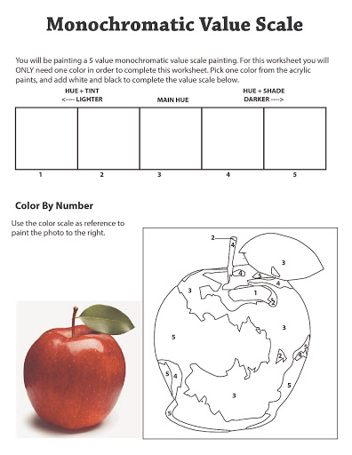

You will be shading a 5 value scale drawing. For this worksheet you will ONLY need one pencil. You can vary your value by changing pressure. Light pressure will create light value, more pressure will create darker value.

